**EMPLOYEE DATABASE Outputs**

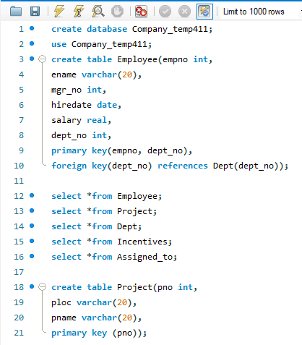

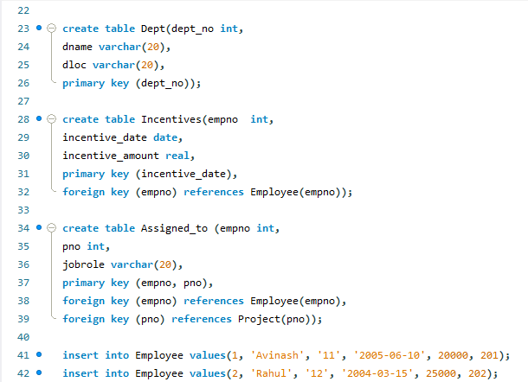

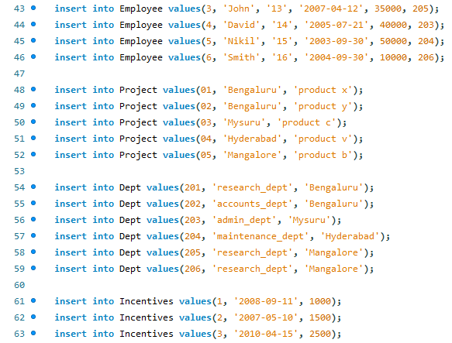

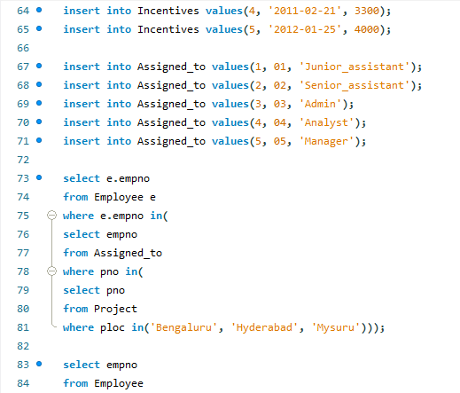

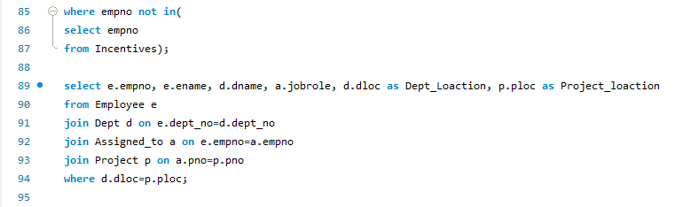

**Queries:**

select e.empno

from Employee e

where e.empno in(

select empno

from Assigned_to

where pno in(

select pno

from Project

where ploc in('Bengaluru', 'Hyderabad', 'Mysuru')));

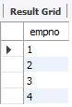

select empno

from Employee

where empno not in(

select empno

from Incentives);



select e.empno, e.ename, d.dname, a.jobrole, d.dloc as Dept_Loaction, p.ploc as Project_loaction

from Employee e

join Dept d on e.dept_no=d.dept_no

join Assigned_to a on e.empno=a.empno

join Project p on a.pno=p.pno

where d.dloc=p.ploc;

